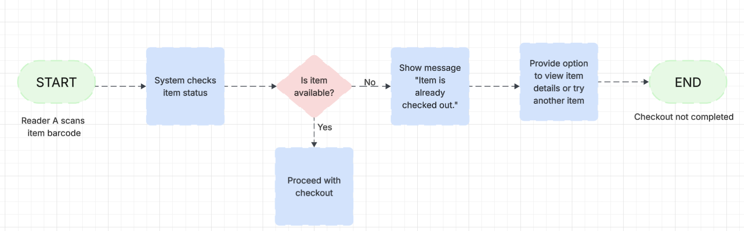

ShelfLife – Exception Path
Scenario: Item is already checked out by another reader (concurrent checkout attempt)

